

Lecture in Finite Element Method

October 1, 2026, University of Split – FESB, C401, 10:15am

Title: Application of advanced MAKOC cyclic plasticity model in ANSYS

Lecturer*: prof. Ing. Radim Halama, Ph.D. (radim.halama@vsb.cz)
Affiliation: VSB-Technical University of Ostrava, Czech Republic

Abstract:
This guest lecture provides an overview of advanced computational and experimental workflows in cyclic plasticity and structural fatigue, bridging experimental material characterization with non-linear finite element analysis (FEA).
The presentation first introduces VSB–Technical University of Ostrava and the advanced research infrastructure at the Faculty of Mechanical Engineering. Key testing facilities will be showcased, including monotonic and low-cycle fatigue (LCF) testing systems, the Split Hopkinson Pressure Bar for high-strain-rate dynamics, as well as industrial additive manufacturing capabilities at the Protolab 3D printing center.
Next, the lecture highlights ongoing activities within the EU COST Action FABER (CA23109), focusing on the international benchmark competition FABEST in LCF and the follow-up Training School organized at the end of July 2026 in Ostrava. Serving as a practical bridge between the competition and finite element modeling, the advanced MAKOC (Modified AbdelKarim-Ohno-Caloch) cyclic plasticity model—implemented as an ANSYS user-material subroutine (USERMAT) and recently released to the public—will be introduced.
The core of the lecture is dedicated to a practical case study: the numerical simulation of force-controlled ratcheting in additively manufactured maraging steel (SLM MS300). The predictive performance of the MAKOC model in capturing non-linear kinematic hardening, mean stress relaxation, and cyclic accumulation of plastic strain will be demonstrated. Finally, the newly prepared user documentation and implementation guidelines for the MAKOC subroutine will be presented, providing researchers and students with a structured manual for calibrating and deploying advanced constitutive models in ANSYS.

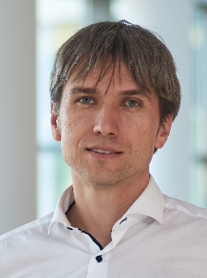
*Biography: Radim Halama is a Professor at the Department of Applied Mechanics, FME, VŠB-Technical University of Ostrava, Czech Republic. He specializes in computational and experimental mechanics, focusing on cyclic plasticity, low-cycle and multiaxial fatigue, creep, and digital image correlation. Currently, he leads the Low-Cycle Fatigue working group (WG 4.7) within the EU COST Action FABER (CA23109 - https://faber-cost.eu/). He has co-authored several book chapters and numerous peer-reviewed journal articles. Additionally, he formerly served as the university's Vice-Rector for International Relations and Social Affairs, and was also responsible for industrial cooperation and technology transfer.

